HOW TO DECIDE WHERE TO LIVE
NAME:
COURSE:
DATE:

How to Decide Where to Live
There are various factors people have to go through when deciding where to live especially with a family. One of the best places to live is Switzerland. Switzerland is a great country from its low crime rate, great health and education standards, to the counties great food.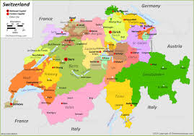
Employment
Switzerland is among the few countries that offer better wages to workers since at time they can be almost triple those offered by other European countries. Switzerland also has smart cities within urban centers. With the smart cities and increased technological advancement towns like Zurich and Geneva, the countries employment opportunities are on the rise which are good for living. With the United Nations and one of the largest banks worldwide situated in the country, many jobs continue to be offered from banking, finance, insurance and world delegation.
Weather and Environment
Switzerland has a moderate weather which does not get too hot or too cold. However, the temperature does vary from different locations where in the north it is cooler while the south gets a bit warmer Pfister, & Brönnimann, (2019). January and February are always the coldest months with the summer temperatures might reach to almost thirty degrees. In terms of environment, Switzerland has a great scenery from the amazing mountains, to its heaps of lakes and the beautiful villages.
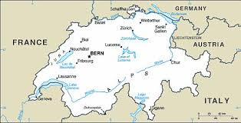
Cost of Living
Switzerland is said to have the expensive homes and many restrictions on buying a house. The restrictions include tourists and foreigners cannot buy houses in Zurich or Geneva but can buy residential property in touristic areas. However, although the houses and cost of living may be high average monthly wages can cover these cost with ease. Rent is higher in the bigger towns like Geneva and Zurich.
Safety
Switzerland has so often been voted one of the safest places to live in brought about by its stable democracy and average living standards. Violent crime is very low although they have the usual petty thieves and pickpockets but in very low numbers. Although the country has suddenly undergone an economic downturn it still remains a safe country with an increase of investors who see it as a safe haven.

Health Services
The life expectancy in Switzerland is very high with seventy-nine years for men and eighty-four for women which is because of their high quality health system. Various legislations have played a role in the high life expectancy like compulsory healthcare insurance for all including all those relocating to the country who are required to apply for insurance within their first three months in the country.
Affordable Housing
Switzerland has very high housing regulations making the cost of owning a house in certain towns like Zurich and Geneva to be very high (Basten & Lassmann, 2017). However, the high wages offered to the works affords the people living in Switzerland to afford residential houses or even lease houses. As compared to their high wages even though the houses may be expensive the Switzerland residents find this affordable.

References
Basten, C., von Ehrlich, M., & Lassmann, A. (2017). Income taxes, sorting and the costs of housing: Evidence from municipal boundaries in Switzerland.
The economic journal, 127(601), 653-687.
Pfister, L., & Brönnimann, S. (2019). Early instrumental meteorological measurements in Switzerland.
Climate of the Past, 15(4), 1345-1361.

